RabbitMQ on Windows

* Prerequisites:

RabbitMQ runs on Erlang virtual machine. So that to install/run the RabbitMQ, initially we have to install the Erlang. If you already installed Erlang on your machine, you can skip this step and directly move to RabbitMQ installation.

* Install Erlang on Windows:

The first step will be to download and install Erlang for Windows. You can obtain the latest installer from  [official website](https://www.erlang.org/downloads).

After downloading and completing the Erlang installation wizard, you should have a new *ERLANG_HOME* environment variable set. If not, you’ll want to set this now so RabbitMQ will be able to locate your installation of Erlang.

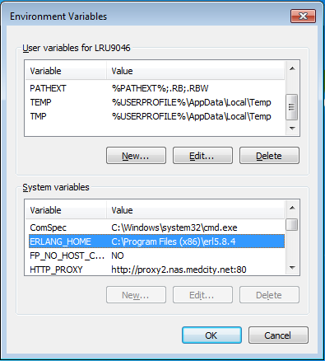

* Install RabbitMQ

download and install the latest version of RabbitMQ for Windows from [here](https://github.com/rabbitmq/rabbitmq-server/releases). By default, the RabbitMQ Windows installer registers RabbitMQ as a Windows service, so technically we’re all ready to go. In addition to the command line utilities provided for managing and monitoring our RabbitMQ instance.

* Start RabbitMQ Server

You Can Start RabbitMQ server by Running **rabbitmq-service.bat start** on **command prompt** on **Administrator Mode**

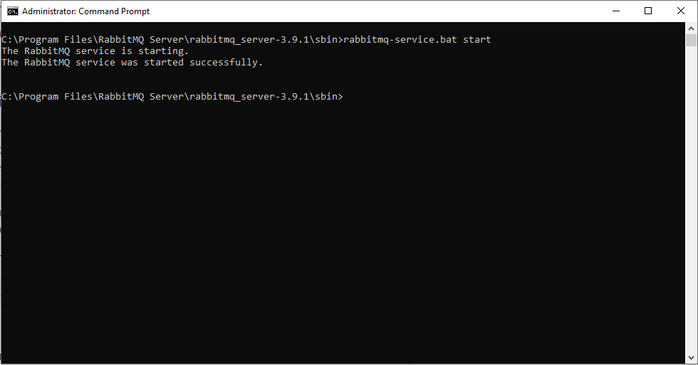

* Stop RabbitMQ Server

You Can Stop RabbitMQ server by Running **rabbitmq-service.bat stop** on **command prompt** on **Administrator Mode**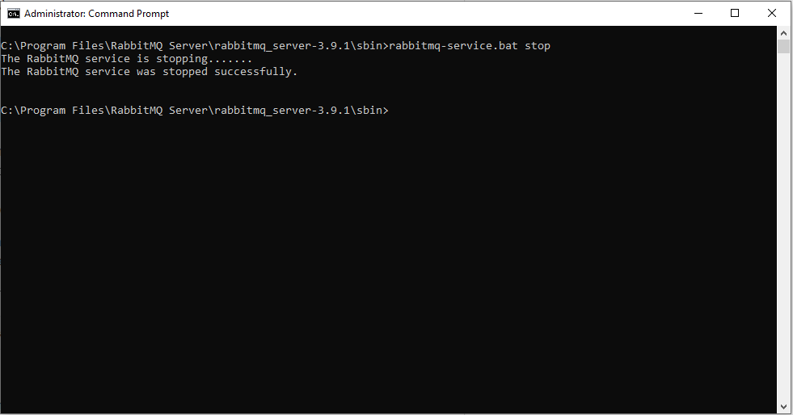

* Enable RabbitMQ Management Plugin

RabbitMQ runs, by default as a windows service, if you are very much interested in working with the command line tool, it’s up to you.

But anyone wants to access it from the web interface, who are need to enable the RabbitMQ management plugin by using the below command on your **command prompt**.

**rabbitmq-plugins.bat enable rabbitmq_management**

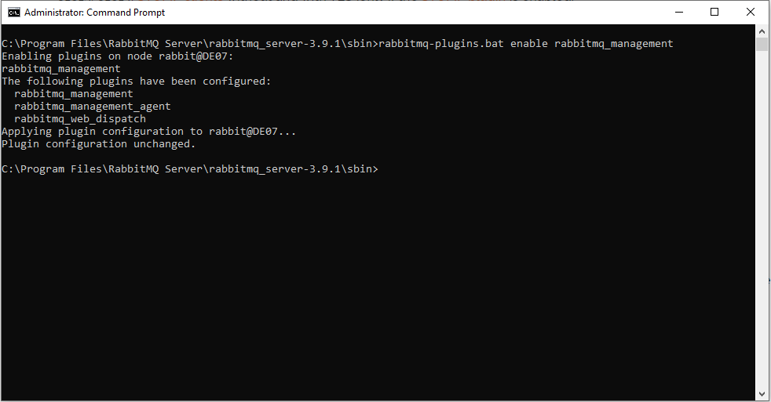

* Navigate RabbitMQ Management Plugin

To check everything as expected open any browser and access the <http://localhost:15672>URL then you would see the below RabbitMQ login page.

Default credentials are:

**User Name**: guest

**Password**: guest

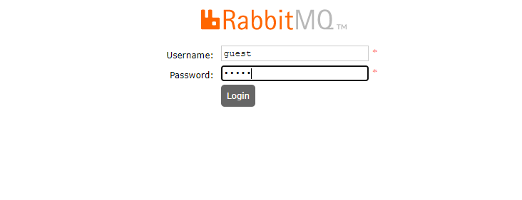

* Navigate RabbitMQ home page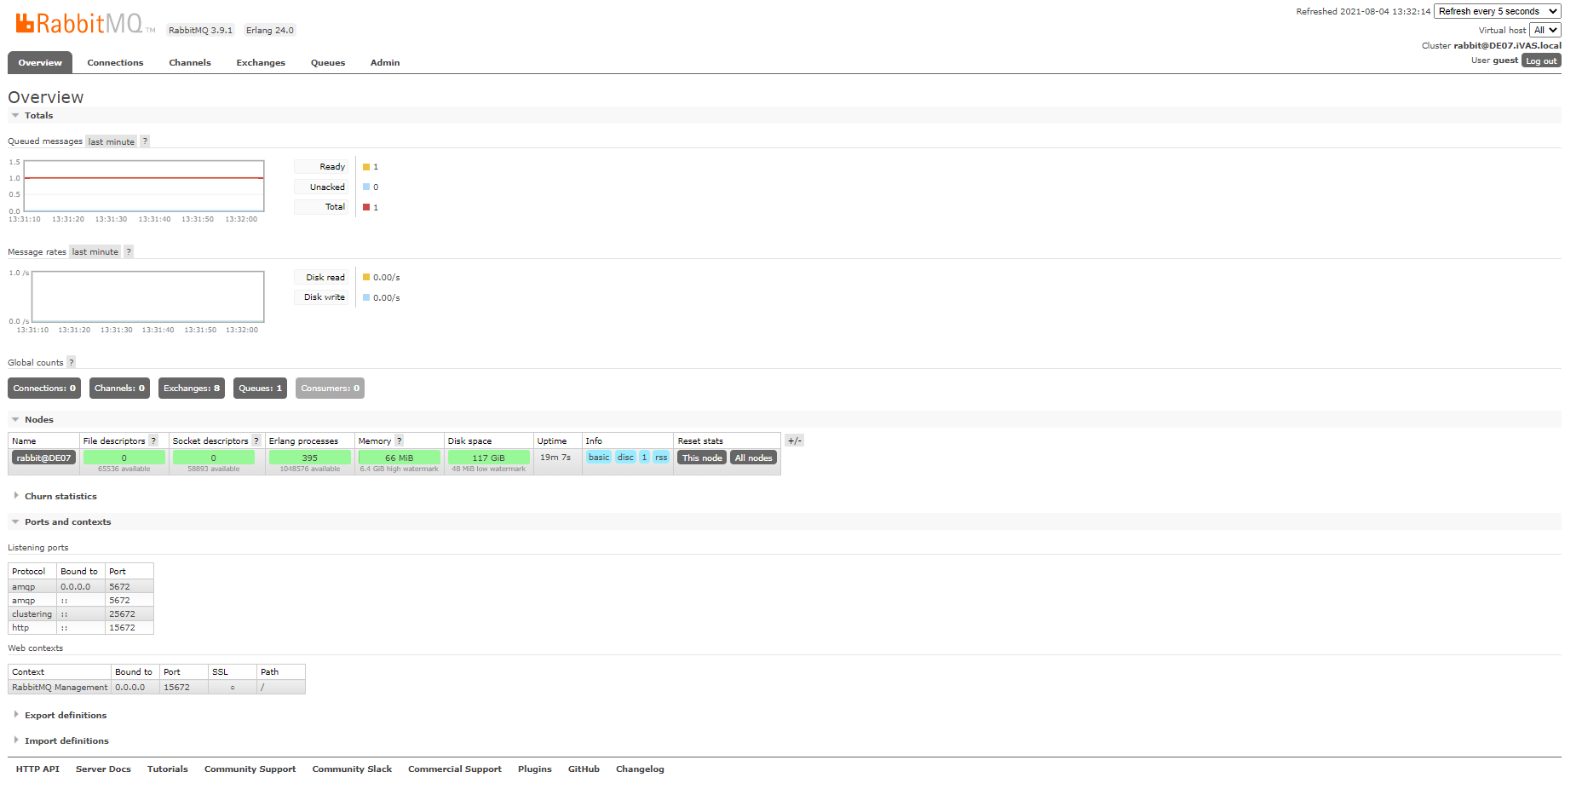
* RabbitMQ Windows Monitor

You can watch message send and received to RabbitMQ by observe the overview section

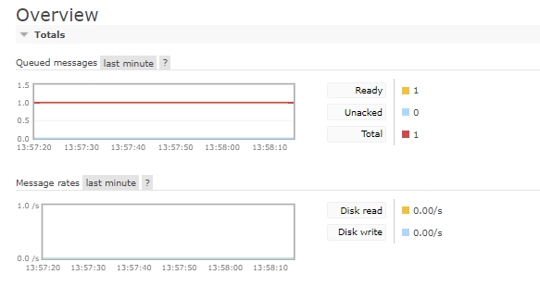

* RabbitMQ Windows Default Configuration for Laravel

